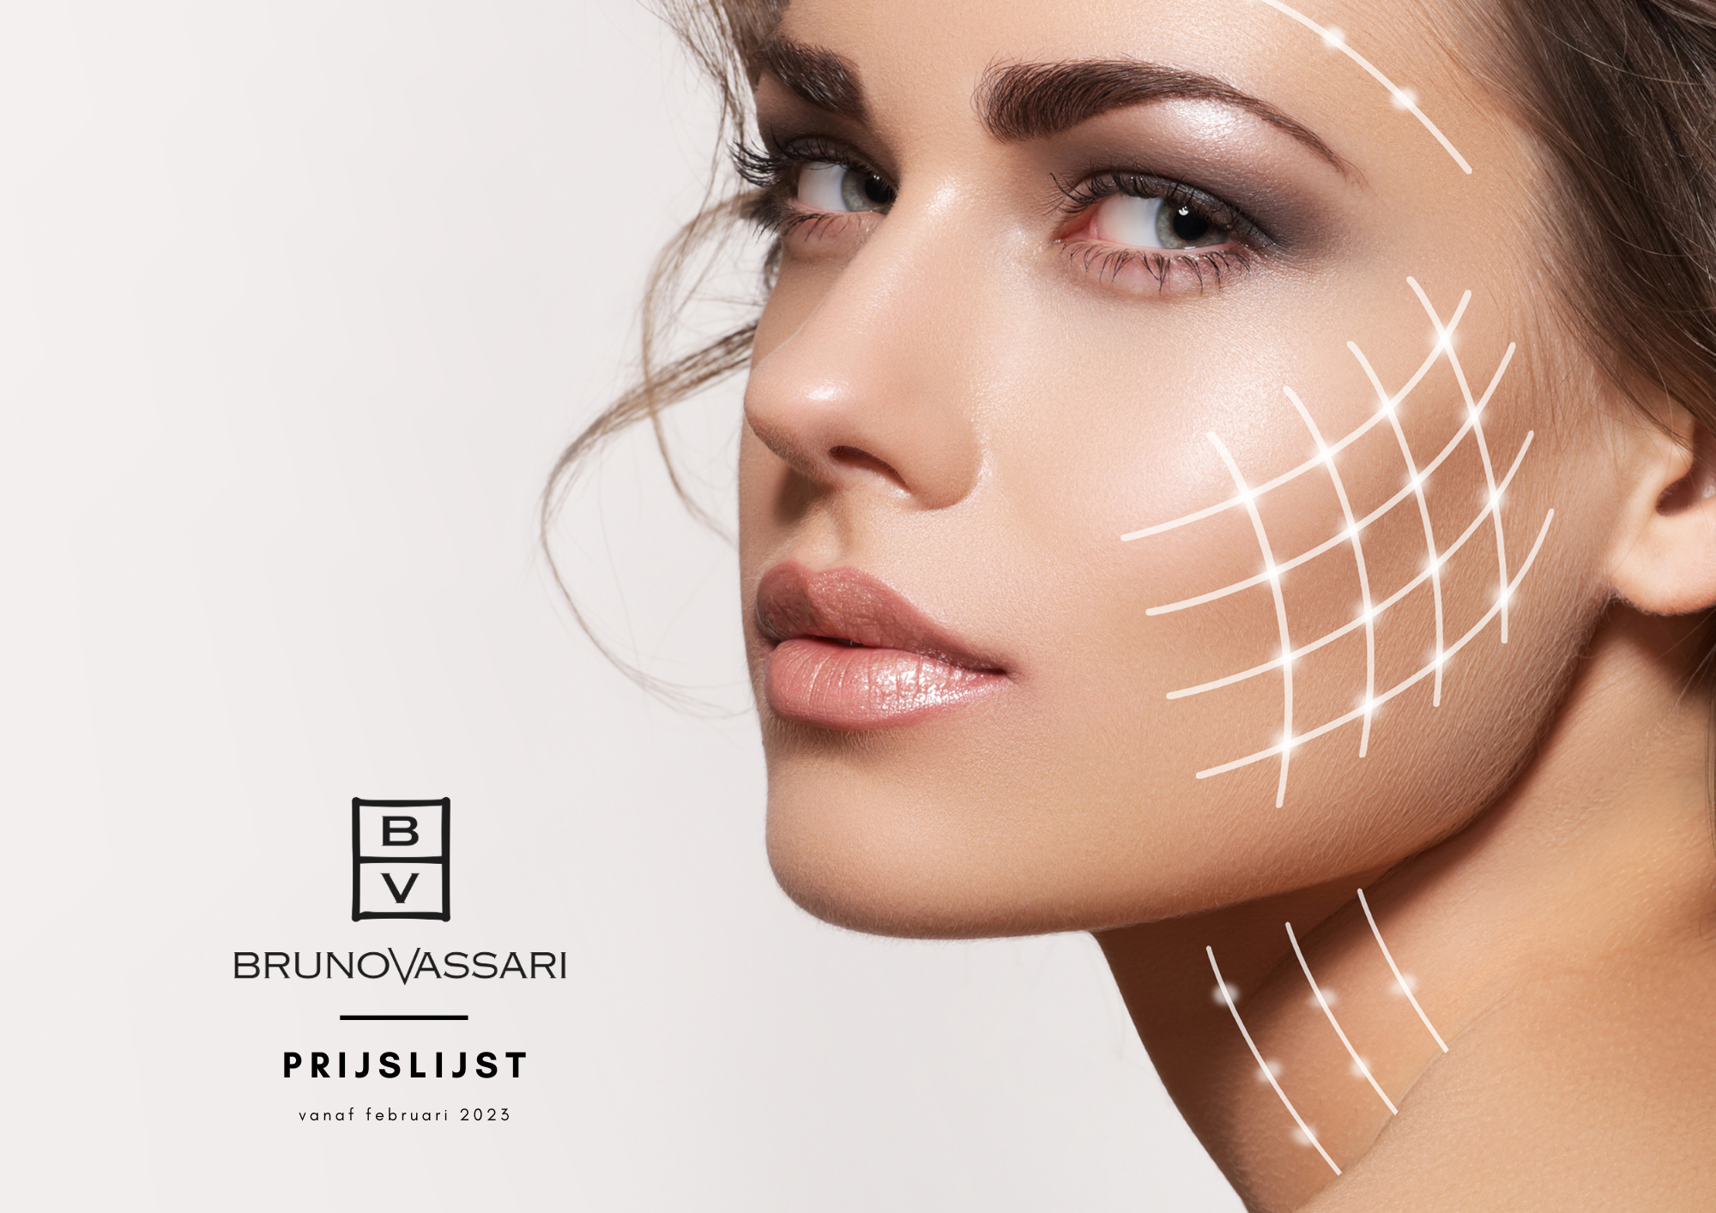

**Bruno Vassari Cosmetics Liste de Prix 2023**

**Prix de vente produits visage:**

|  |  |  |  |  |  |  |  |
| --- | --- | --- | --- | --- | --- | --- | --- |
| DESCRIPTION | Ref. | Ml/gr/pcs | | Achat € | | Vente € | |
| THE BASICS – LIGNE DE BASE | | | | | **Excl.BTW** | | **Incl.BTW** | |
| Aqua Pura | 0309 | | 250 | | 16,80 | | 33,60 | |
| Bio Douce | 0310 | | 150 | | 13,65 | | 27,30 | |
| Eye Gel-Cream | 0311 | | 50 | | 24,60 | | 49,20 | |
| Cream | 0312 | | 50 | | 29,55 | | 59,10 | |
| Body Lotion | 0313 | | 500 | | 26,10 | | 52,20 | |
| Soap Bar | 0315 | | 1 | | 7,59 | | 15,18 | |
| Pack The Basics | 9741 | | 4 | | 78,00 | | 156,00 | |
| Reusable Make-Up Remover Pads | 9080 | | 15 | | 19,50 | | 39,00 | |
| Lemon Breeze Hand Cleaner | 0344 | | 0344 | | 12,60 | | 25,20 | |

|  |  |  |  |  |
| --- | --- | --- | --- | --- |
| DESCRIPTION | Ref. | Ml/gr/Pcs | Achat € | Vente € |
| SKIN COMFORT LIGNE – PEAUX SENSIBLES | | | **Excl.TVA** | **TVA incl.** |
| Fresh Cleansing Fluid | 0200 | 250 | 16,50 | 33 |
| Refreshing Toner | 0201 | 250 | 16,50 | 33 |
| Calming Day Lotion | 0220 | 50 | 28,35 | 56,70 |
| Gentle Night Cream | 0221 | 50 | 23,40 | 46,80 |
| Eye Contour Gel | 0222 | 15 | 28,80 | 57,60 |
| Skin Restore Plus | 0249 | 50 | 30,60 | 61,20 |
| Stop Redness | 0224 | 50 | 30,90 | 61,80 |

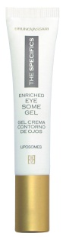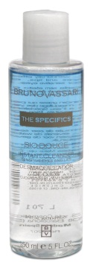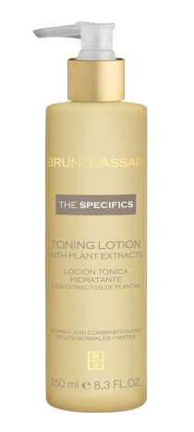

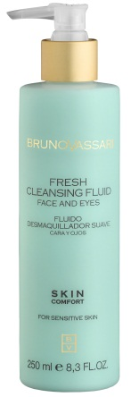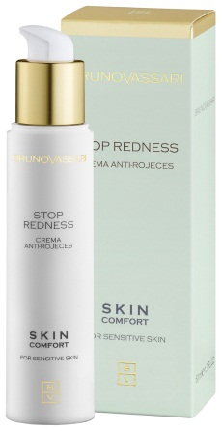

|  |  |  |  |  |  |  |
| --- | --- | --- | --- | --- | --- | --- |
| DESCRIPTION | Ref. | Ml/gr/pcs | | Achat € | | Vente € |
| WHITE LIGNE - TACHES PIGMENTAIRES |  |  | **Excl.BTW** | | **Incl.BTW** | |
| White Brightening Lotion | 0206 | 250 | 23,70 | | 47,40 | |
| White Day Protection SPF 15 | 0231 | 50 | 30 | | 60 | |
| White Light(verbleking van vlekken) | 0232 | 30 | 31,80 | | 63,60 | |
| White Pure C | 0233 | 3x8 | 38,70 | | 77,40 | |
| White Brightening Essence Gel | 0234 | 30 | 41,25 | | 82,50 | |
| White Creamy Cleansing Foam | 0235 | 150 | 24,75 | | 49,50 | |
| White Targeted Brightening Care | 0328 | 100 | 39,45 | | 78,90 | |

|  |  |  |  |  |  |  |  |  |
| --- | --- | --- | --- | --- | --- | --- | --- | --- |
| DESCRIPTION | Ref. | | Ml/gr/pcs. | | Achat € | | Vente€ | |
| PURE SOLUTIONS LIGNE – PEAUX GRASSES ET MIXTES | | | | | **Excl.TVA** | | **Incl.TVA** | |
| Pure Solutions Cleansing Gel | | 0212 | 150 | 18 | | 36 | |
| Pure Solutions Akno-Control Lotion | | 0211 | 250 | 19,05 | | 38,10 | |
| Pure Solutions Balancing Toner | | 0210 | 250 | 19,20 | | 38,40 | |
| Pure Solutions Balance Fluid | | 0213 | 50 | 27,90 | | 55,80 | |
| Pure Solutions Corrective Cream | | 0215 | 50 | 16,05 | | 32,10 | |
| Pure Solutions Oil-Free Moist.Gel | | 0214 | 50 | 24,45 | | 48,90 | |

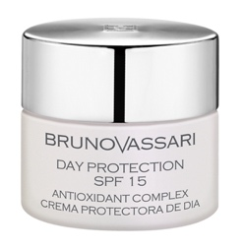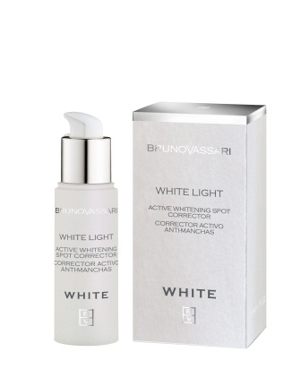

|  |  |  |  |  |
| --- | --- | --- | --- | --- |
| DESCRIPTION | Ref. | Ml/gr/pcs | Achat € | Vente € |
| AHA LIGNE |  |  | **Excl.TVA** | **Incl.TVA** |
| AHA Multi - Effect Cream (glycolzuur 4%) | 0225 | 50 | 37,60 | 75,20 |
| AHA Glycolic Cream 10 (glycol 10%) | 0228 | 50 | 40,10 | 80,20 |
| AHA Skin Cleanser | 2225 | 250 | 53,00 | 106 |

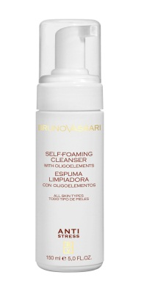

|  |  |  |  |  |
| --- | --- | --- | --- | --- |
| DESCRIPTION | Ref. | Ml/gr/pcs | Achat € | Vente € |
| ANTI-STRESS LIGNE ( TOUS TYPES DE PEAUX) |  |  | **Excl.TVA** | **Incl.TVA** |
| Anti-Stress Foaming Cleanser | 0205 | 150 | 19,80 | 39,60 |
| Anti-Stress Daily Cream (dag-nachtcr.norm.h.) | 0227 | 50 | 26,10 | 52,20 |
| Anti-Stress Daily Cream (dag-nachtcr.droge h.) | 0226 | 50 | 27,15 | 54,30 |

|  |  |  |  |  |
| --- | --- | --- | --- | --- |
| DESCRIPTION | Ref. | Ml/gr/Pcs | Achat € | Vente € |
| KIANTY EXPERIENCE LIGNE |  |  | **Excl.TVA** | **Incl.TVA** |
| Fresh Foam Cleanser/ Rugiada di Vigna | 0250 | 150 | 22,20 | 44,40 |
| Grape Juice/ Pioggia di Vigna | 2326 | 200 | 22,20 | 44,40 |
| Essential Fluid Care/ Mosto | 0254 | 50 | 40,05 | 80,10 |
| Active Anti-Aging Care/ Paté d'Uva | 0252 | 50 | 33,45 | 66,90 |
| Vita-Vite crème | 0255 | 50 | 43,65 | 87,30 |
| SerumVite | 0257 | 50 | 55,80 | 111,60 |
| Kianty Eye Lift Ox | 0256 | 15 | 39,45 | 78,90 |
| Kianty Viniferin Eyes & Lips Cream | 0267 | 15 | 40,20 | 80,40 |

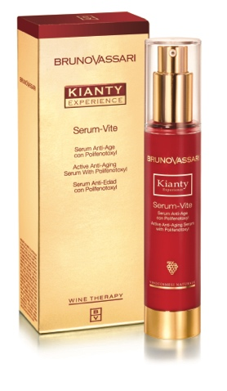

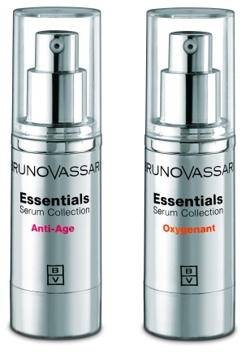

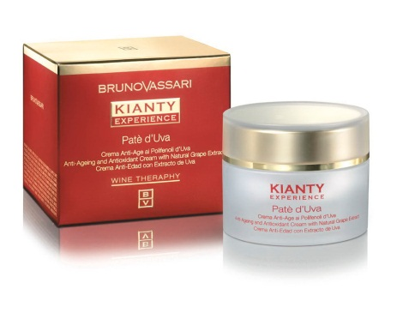

|  |  |  |  |  |
| --- | --- | --- | --- | --- |
| DESCRIPTION | Ref. | Ml/gr/pcs | Achat € | Vente € |
| LAB RADIANCE |  |  | **Excl.TVA** | **Incl.TVA** |
| Lab Radiance Brightness Reveal Cream | 0360 | 50 | 52,50 | 105,00 |
| Lab Radiance Illuminating Eye Contour | 0361 | 15 | 32,25 | 64,50 |
| Lab Radiance Instant Glow Beauty | 0362 | 2x30 | 57,45 | 114,90 |

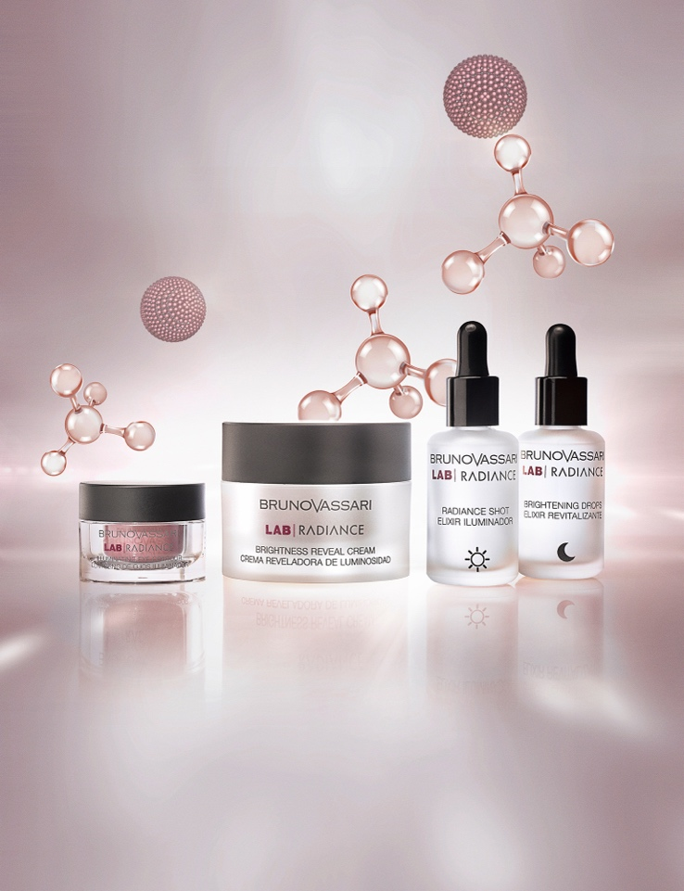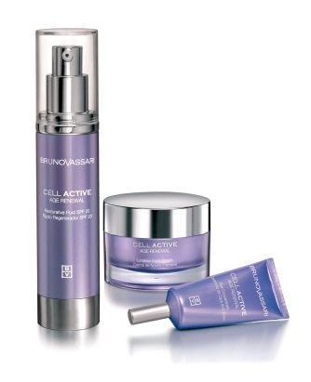

|  |  |  |  |  |  |
| --- | --- | --- | --- | --- | --- |
| DESCRIPTION | | Ref. | Ml/gr/pcs | Achat € | Vente € |
| LAB DIVISION - BOOSTERS NEW!! |  | |  | **Excl.TVA** | **Incl.TVA** |
| Lab Division Boosters – Stop Blemish | 0320 | | 15 | 40,50 | 81,00 |
| Lab Division Boosters – Inner Light | 0321 | | 15 | 40,50 | 81,00 |
| Lab Division Boosters – Breathing Skin | 0322 | | 15 | 40,50 | 81,00 |
| Lab Division Boosters – Face Lift | 0323 | | 15 | 40,50 | 81,00 |
| Lab Division Boosters- Lifting&Firming Cream | 0324 | | 50 | 47,40 | 94,80 |
| Lab Division Boosters – Daily Reviving Cream | 0325 | | 50 | 47,40 | 94,80 |

|  |  |  |  |  |
| --- | --- | --- | --- | --- |
| DESCRIPTION | Ref. | Ml/gr/pcs | Achat € | Vente € |
| ESSENTIAL SERUM COLLECTION |  |  | **Excl.TVA** | **Incl.TVA** |
| Serum Anti-Age | 0246 | 30 | 45,45 | 90,90 |
| Serum Oxygenant | 0247 | 30 | 45,00 | 90,00 |

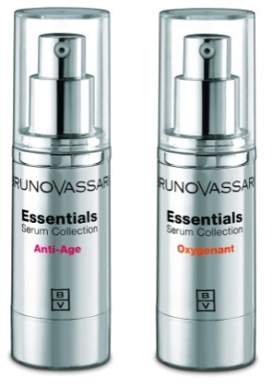

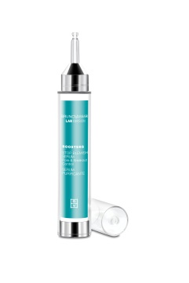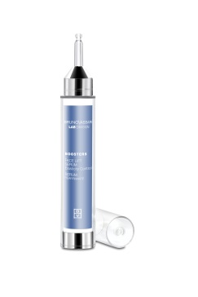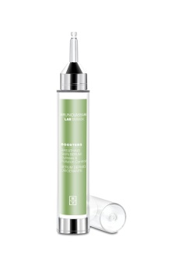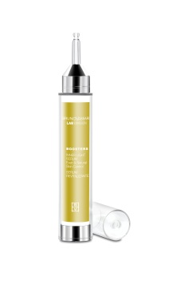

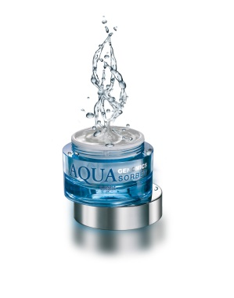

|  |  |  |  |  |
| --- | --- | --- | --- | --- |
| DESCRIPTION | Ref. | Ml/gr | Achat € | Vente € |
| AQUA GENOMICS |  |  | **Excl.TVA** | **Incl.TVA** |
| Aqua Genomics Cleansing | 0264 | 250 | 20,25 | 40,5 |
| Aqua Genomics Toner | 0263 | 250 | 17,40 | 34,80 |
| Aqua Genomics Sorbet Light | 0266 | 50 | 43,95 | 87,90 |
| Aqua Genomics Sorbet Rich | 0265 | 50 | 48,75 | 97,50 |

|  |  |  |  |  |
| --- | --- | --- | --- | --- |
| DESCRIPTION | Ref. | Ml/gr | Achat € | Vente € |
| LAB DIVISION – COLLAGEN BOOSTER |  |  | **Excl.TVA** | **Incl.TVA** |
| Collagen Booster - Enzyme Cleansing Powder | 0271 | 50 | 30,60 | 61,20 |
| Collagen Booster - Clarifying Milky Toner | 0272 | 200 | 33 | 66 |
| Collagen Booster - C+C Synergy Serum | 0302 | 10*3ml | 55,80 | 111,6 |
| Collagen Booster - Power C Peptides Cream | 0274 | 50 | 61,05 | 122,10 |
| Collagen Booster – Peptide Night Cream | 0276 | 50 | 61,05 | 122,10 |
| Collagen Booster - Peptide Eye Contour Gel Cream | 0277 | 15 | 29,70 | 59,40 |
| Collagen Booster – Vitamin C Blur | 209 | 2*10ml | 21,75 | 43.50 |

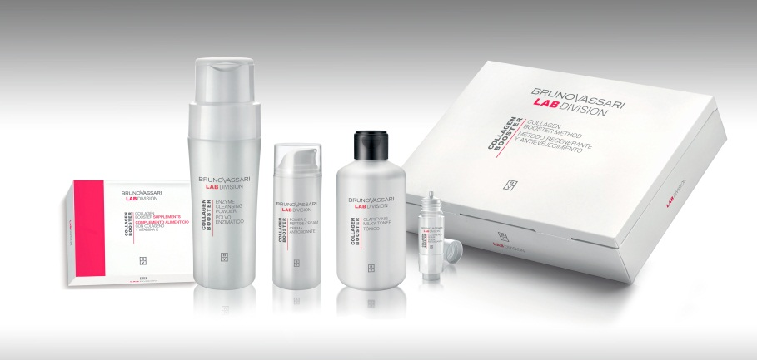

|  |  |  |  |  |
| --- | --- | --- | --- | --- |
|  | Ref. | Ml/gr | Achat € | Vente € |
| LAB DIVISION – GLYCO SYSTEM |  |  | **Exl.BTW** | **Incl.BTW** |
| Glyco System - Glycolic Washing Foam | 0280 | 150 | 20,85 | 41,70 |
| Glyco System - Dual Phase Toner | 0281 | 200 | 21,90 | 43,80 |
| Glyco System – Intensive Glyco C Serum | 0282 | 30 | 51,30 | 102,60 |
| Glyco System - Protective Cream SPF25 | 0283 | 50 | 33 | 66 |
| Glyco System Glycolic Exfoliating Pads | 0279 | 30 | 38,40 | 76,80 |
| Glyco System Charcoal Mask | 294 | 50 | 22,50 | 45 |

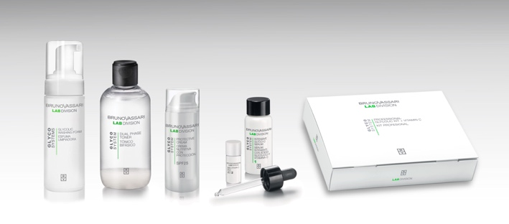

|  |  |  |  |  |
| --- | --- | --- | --- | --- |
| DESCRIPTION | Ref. | Ml/gr | Achat € | Vente € |
| LAB DIVISION – HA50X | | | **Excl.TVA** | **Incl.TVA** |
| HA50X – Hyaluronic Cream Pollution Neutralizer | 0297 | 50 | 43,50 | 87,00 |
| HA50X – Hyaluronic Multi Molecular Filler | 0298 | 15 | 28,50 | 57,00 |
| HA50X – Hyaluronic Sleeping Mask | 0299 | 50 | 43,50 | 87,00 |
| HA50X – Hyaluronic Scrub & Mask | 0300 | 100 | 22,50 | 45,00 |
| HA50X – Premium Hyaluronic Oil | 0301 | 30 | 36,00 | 72,00 |
| HA50X – 4D Hyaluronic Acid + B5 | 1048 | 6 x 2 | 22,05 | 44,10 |

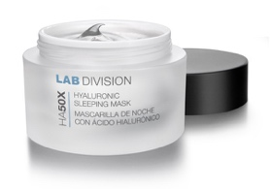

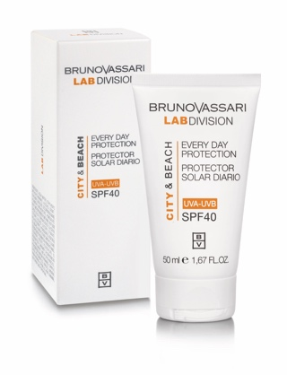

|  |  |  |  |  |
| --- | --- | --- | --- | --- |
| DESCRIPTION | Ref. | Ml/gr/pcs | Achat € | Vente € |
| LAB DIVISION – CITY & BEACH | | | **Excl.TVA** | **Incl.TVA** |
| City & Beach – Everyday Protection SPF 40  City & Beach- Everyday Prot. Color SPF40 | 0278  0308 | 50  50 | 29,85  29.85 | 59,70  59,70 |
| City & Beach – Everyday Prot. SPF 40 | 2352 | 200 | 49,05 | 98,10 |
| Expositor City & Beach + City & Beach Color | 7221 | 10+2 | 336 |  |

|  |  |  |  |  |
| --- | --- | --- | --- | --- |
| DESCRIPTION | Ref. | Ml/gr | Achat € | Vente € |
| LAB DIVISION – LAB BIOTICS |  |  | **Excl.TVA** | **Incl.TVA** |
| Lab Biotics – Dermal Relief Cream | 0330 | 100 | 49,05 | 98,10 |
| Lab Biotics – Skin Defense Boosters Caps. | 0331 | 60 | 58,50 | 117,00 |
| Lab Biotics – Extra Rich Cleansing Foam | 0332 | 150 | 25,35 | 50,70 |
| Lab Biotics – Daily Mist Toner | 0333 | 200 | 28,80 | 57,60 |
| Lab Biotics – Lactis Advanced Cream | 0334 | 50 | 50,70 | 101,40 |

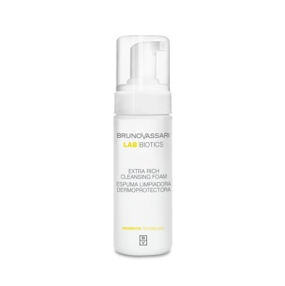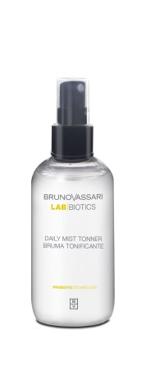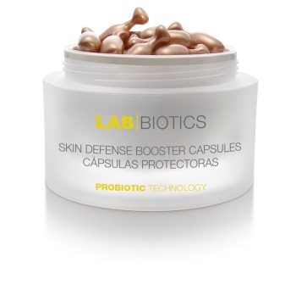

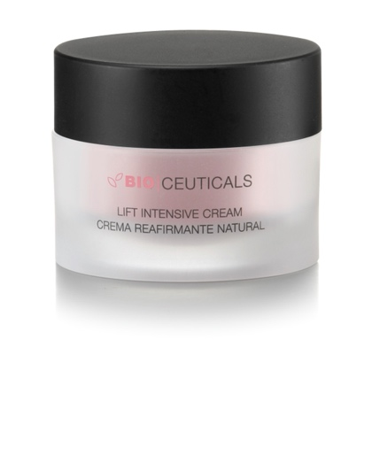

|  |  |  |  |  |
| --- | --- | --- | --- | --- |
| DESCRIPTION | Ref. | Ml/gr | Achat € | Vente € |
| LAB DIVISION – BIOCEUTICALS |  |  | **Excl.TVA** | **Incl.TVA** |
| Lift Intensive Cream | 0340 | 50 | 46,35 | 92,70 |
| C+Ferulic+DMAE | 0341 | 6*2ML | 29,55 | 59,10 |
| Fast Flash Beauty | 0342 | 6*2ML | 21,30 | 42,60 |
| Intensive Firming Pack | 9732 | 50ml+7*2ML | 60,00 | 120,00 |

**PRIX VENTE POUR LE CORPS:**

|  |  |  |  |  |
| --- | --- | --- | --- | --- |
| DESCRIPTION | Ref. | Ml/gr/pcs | Achat € | Vente € |
| BODY CARE – LIGNE CORPORELLE |  |  | **Excl.TVA** | **Incl.TVA** |
| Body Care Double Body Peel | 0284 | 200 | 24,30 | 48,60 |
| Body Care Cellulite Control | 0285 | 200 | 39,45 | 78,90 |
| Body Care Slim Effect Gel | 0286 | 200 | 38,10 | 76,20 |
| Body Care Premium Firming Cream | 0287 | 200 | 44,85 | 89,70 |
| Body Care Strialia | 0288 | 200 | 40,80 | 81,60 |
| Body Care Age Control Hand Cream | 0289 | 75 | 7,92 | 15,84 |
| Body Care Gel Caribel | 0291 | 500 | 14,85 | 29,70 |
| Body Care Geraldina | 0292 | 500 | 18,60 | 37,20 |
| Body Care Bust Beauty Gel | 0293 | 100 | 34,50 | 69 |
| Body Care Epil Retard | 0290 | 100 | 30,75 | 61,50 |
| Body Care- Thermo Body Fit | 0306 | 200 | 42,30 | 84,60 |
| Body care-Silhouette Designer Stick | 0307 | 1 | 31,20 | 62,40 |
| Firm & Sculpt Concentrate | 0350 | 6x10 | 30,45 | 60,90 |

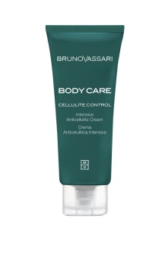

**PRODUITS DE CABINE POUR LE SOIN DE VISAGE:**

|  |  |  |  |
| --- | --- | --- | --- |
| DESCRIPTION | ref. | ml/gr | Achat € |
| AMPOULES |  |  |  |
| The Basics moisturizing Concentrate | 1049 | 10 x 2ml | 29,70 |
| Facial Revitalizante | 1045 | 10 x 3ml | 44,55 |
| AHA Ampullen | 1043 | 10 x 3ml | 142,30 |
| Lacrime d'UVA | 1042 | 10 x 2ml | 33 |
| White - Intensive Whitening concentrate | 1046 | 10 x 2ml | 33,90 |
| Pure Solutions - Oil Control Concentrate | 1047 | 10 x 2ml | 34,65 |
| Body Care-Cellulite Control Concentrate  Body Care Firm&Sculpt Concentrate | 1056  1066 | 10 x 10ml  10 x10ml | 56,55  50,70 |
| Lab Division Boosters – Radiance Plus | 2331 | 30ml | 42,30 |
| Lab Division Boosters – 02 Detox | 2332 | 30ml | 42,30 |
| Lab Division Boosters – Skin Relief | 2333 | 30ml | 42,30 |
| Lab Division Boosters – Skin Clarifier | 2334 | 30ml | 42,30 |
| Lab Division Boosters – Ultra Firm | 2335 | 30ml | 42,30 |
|  |  |  |  |

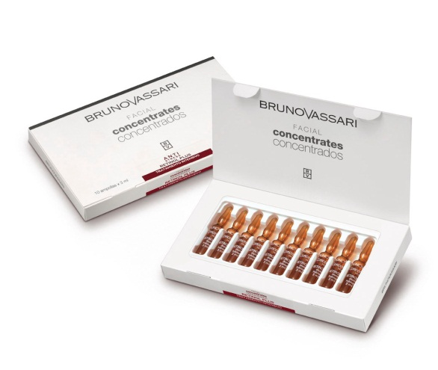

|  |  |  |  |
| --- | --- | --- | --- |
| LOTIONS |  |  |  |
| Pure Sol. Akno Control Lotion | 2209 | 500 | 25,50 |
| Pure Solutions Balancing Toner | 2208 | 500 | 25,80 |
| Refreshing Toner (gevoelige huid) | 2201 | 500 | 23,25 |
| The Basics Aqua Pura | 2349 | 500 | 24,60 |
| Kianty – Pioggia Di Vigna, Grape Juice | 2261 | 500 | 33 |
| White Brightening Lotion | 2205 | 500 | 33,30 |
| Aqua Genomics Toner | 2212 | 500 | 24,75 |
| Lab Biotics – Daily Mist Toner  Collagen Booster-Activating Lotion | 2341  2303 | 500  200 | 37,20  25,35 |

|  |  |  |  |
| --- | --- | --- | --- |
| LAITS NETTOYANTS |  |  |  |
| Pure Solutions Cleansing Gel | 2211 | 250 | 23,85 |
| Fresh Cleansing Fluid (gevoelige huid) | 2200 | 500 | 23,25 |
| Kianty - Nettare D'Uva | 2269 | 500 | 33,45 |
| White - Creamy Cleansing Foam | 2241 | 250 | 32,10 |
| Aqua Genomics Cleansing | 2213 | 500 | 31,20 |

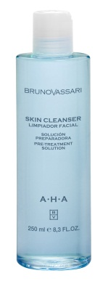

|  |  |  |  |  |
| --- | --- | --- | --- | --- |
| PEELINGS | Ref. | Ml/gr | | Achat € |
| AHA Skin Cleanser | 2225 | 250 | 53,00 | |
| Gentle Exfoliating Gel/ Frappé di Vite | 2264 | 200 | 36,15 | |
| Collagen Booster – Microderm Polish Powder | 2300 | 50 | 34,80 | |
| Lab Division Boosters – Papain Enzimatic Resurfacer | 2336 | 200 | 33,90 | |

|  |  |  |  |  |
| --- | --- | --- | --- | --- |
| CREMES VISAGE | Ref. | Ml/gr | Achat€ |  |
| AHA Multi-Effect Cream | 2223 | 200 | 69,20 |  |
| Anti-Stress Daily Cream (dry skin) | 2226 | 200 | 48,15 |  |
| Anti-Stress Daily Cream (normal skin) | 2232 | 200 | 47,55 |  |
|  |  |  |  |  |
| White - Day Protection SPF15 | 2229 | 200 | 52,65 |  |
| Gentle Night Cream | 2221 | 200 | 44,40 |  |
| Kianty – Mosto | 2268 | 200 | 55,65 |  |
| Kianty - Paté d'Uva | 2267 | 200 | 48,90 |  |
| Vita Vite | 2248 | 200 | 74,10 |  |
| Skin Restore Plus | 2306 | 200 | 54,75 |  |
| Anti-Stress – Vitalising Massage Cream | 0244 | 200 | 40,65 |  |
| Aqua Genomics Sorbet Rich | 2214 | 200 | 72,75 |  |
| Lab Division Boosters – The True Cream | 2337 | 200 | 25,35 |  |
| Lab Division Boosters – Massage gel | 2338 | 200 | 39 |  |

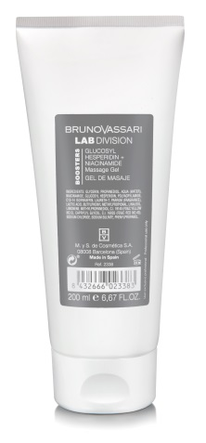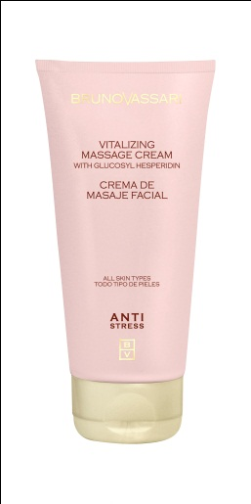

|  |  |  |  |  |
| --- | --- | --- | --- | --- |
| MASQUES | Ref. | Ml/gr/pcs. | Achat € |  |
| Pure Solutions Balancing Mask | 2210 | 200 | 25,05 |  |
| Gentle Soothing Mask | 2222 | 200 | 26,40 |  |
| The Basics Hydro Intensive Mask | 2347 | 200 | 26,10 |  |
| The Basics Mask Some | 2345 | 200 | 57,45 |  |
| Skin Whitening Mask | 2230 | 200 | 44,55 |  |
| The Basics Spiruline Modeling Mask | 2348 | 6 | 57,90 |  |
| Kianty - Bacco E Venere/ Modeling Mask | 2263 | 6 | 64,20 |  |
| White - Intensive Whitening Mask | 2237 | 6 | 60,90 |  |
| Pure Solutions - Oily Control Mask | 2284 | 6 | 60,90 |  |
| Glyco System Charcoal Mask | 2324 | 200 | 32,25 |  |
| Lab Division Boosters – Second Skin Mask | 2339 | 5 | 109,95 |  |

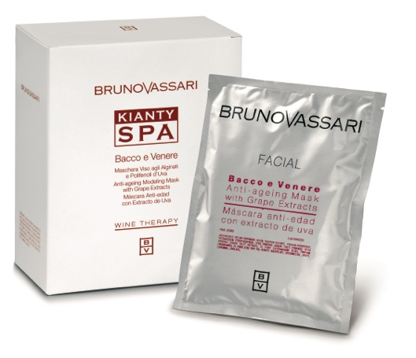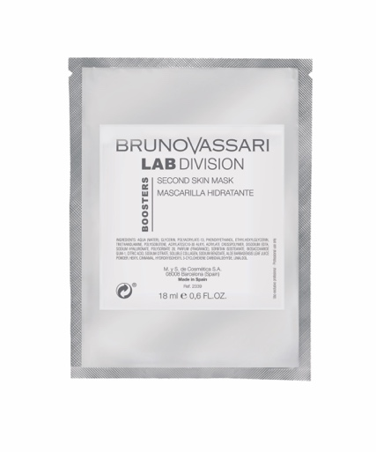

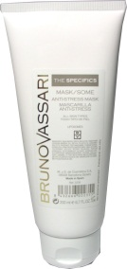

|  |  |  |  |
| --- | --- | --- | --- |
| SPECIAL TREATMENT PACKS |  |  |  |
| Eye Contour Treatment | 2228 | 5 | 63,90 |
| White - Intensive Whitening Treatment | 2239 | 6 | 121,95 |
| Aqua Genomics Self-Moisturizing Treat. | 2277 | 6 | 127,05 |
| Pure Solutions – Oil Control Treat. | 2283 | 6 | 121,95 |
| Kianty Viniferin Visible Results | 2288 | 6 | 105,75 |
| Lab Division – Collagen Booster Method | 2304 | 5 | 269,40 |
| Lab Division -Glyco System - Professional Glycolic Kit + Vitamin C | 2305 | 6 | 94,65 |
| HA50X – Hyaluronic Professional Kit | 2325 | 6 | 135,30 |
| Lab Biotics – Probiotic Professional Kit  Bioceuticals-Global Firming Care | 2340  2343 | 6  6 | 126,90  131,40 |

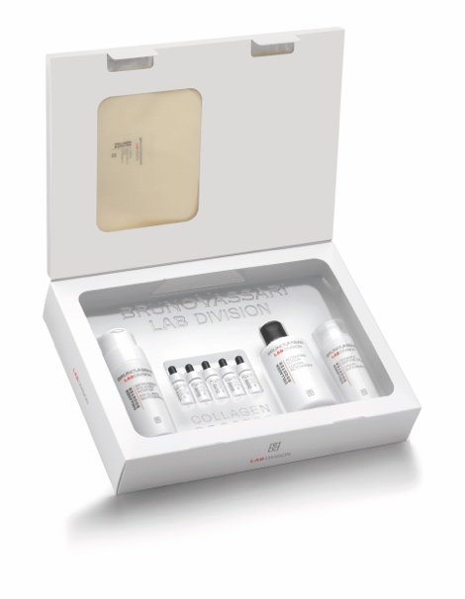

**PRODUITS DE CABINE POUR LE CORPS:**

|  |  |  |  |
| --- | --- | --- | --- |
| DESCRIPTION | Ref. | Ml/gr | Achat € |
| SPECIAL BODY PRODUCTS |  |  |  |
| Body Care – Crema Masaje Anticelulitica | 2313 | 1000 | 78,75 |
| Cellulite Body Mask | 2116 | 2000 | 154,20 |
| Ederalis Koude Vloeistof met algen | 2314 | 1000 | 52,05 |
| Body Care - Exudation-crème (parrafinecrème vr. pakking) | 2319 | 1000 | 53,10 |
| Body Care - Massage-olie met eth.oliën | 2315 | 500 | 36,45 |
| Body Care - Thermo-Actieve crème | 2310 | 200 | 27,90 |
| Body Care - Thermo-Actieve crème (opwarmende cr,) | 2316 | 1000 | 78,75 |
| Body Care-Premium firming Cream | 2307 | 1000 | 107,55 |
| Body care-Slim-Effect Gel | 2308 | 1000 | 101,10 |
| Body Care-Hand & Foot paraffin mask | 2328 | 500 | 40,5 |
| Body care –Hand&Foot Silky Touch | 2329 | 200 | 19,65 |
| UVAslim | 2274 | 1000 | 86,25 |
| Kianty Spa – Mousse Thermal | 2291 | 1000 | 81,60 |
| Kianty Spa – Mousse Thermal | 2292 | 4000 | 224,55 |
| Body Care - Snow Firming Mask | 2309 | 1000 | 98,70 |
| Body Care - Double Body Peel | 2312 | 500 | 53,85 |
| Body Care - Sculpt Plaster | 2311 | 4x440 | 116,55 |
| Conc. Cellulite Control  Body Care-Hand & Foot Silky Touch  Body Care-Hand & Foot Paraffin Mask  Kianty Spa-Olio Di Vinaccioli All’Uva  Kianty Spa-Il sale E L’Uva  Kianty Spa-cocktail di Algue e Uva  Kianty Spa-Uvaslim  Kianty Spa-vigna Del Mar | 2322  2329  2328  2262  2271  2273  2274  2282 | 10x10  200  500  500  350  500  1000  2000 | 56,55  19,65  40,50  43,80  44,40  66,85  86,25  156,90 |

|  |  |  |  |
| --- | --- | --- | --- |
| DESCRIPTION | Ref. | Ml/gr/pcs | Achat € |
| EPILATION |  |  |  |
| Kianty roll-on harscasette met druivenextr. | 1009 | 1 | 4,45 |
| Papieren strips | 1020 | 100 | 21,00 |
| Roze schijven lauwe was | 1024 | 1 | 29,25 |
| Witte was in schijven | 1018 | 1 | 35,15 |

|  |  |  |  |  |
| --- | --- | --- | --- | --- |
| DESCRIPTION | Ref. | Ml/gr/pcs | Achat € | Vente € |
| SENSES – CANDLE MASSAGE |  |  |  |  |
| Senses Natural Cocktail Scrub | 2249 | 200 | 73,50 | / |
| Senses Massage Candle - Monoi | 2280 | 200 | 66,60 | / |
| Senses Massage Candle - Jasmine | 2281 | 200 | 66,60 | / |
| SENSES – COCONUT RITUAL |  |  |  |  |
| Coconut Body Milk | 0364 | 400 | 31,20 | 62,40 |
| Sweet & Salty Massage Peel | 2354 | 650 | 106,80 | / |
| Coconut Pulp Body Pack | 2355 | 3000 | 188,85 | / |
| Relaxing & Preparing Balm | 2356 | 500 | 41,10 | / |
| Coconut Body Milk | 2357 | 500 | 32,10 | / |
|  |  |  |  |  |
|  |  |  |  |  |

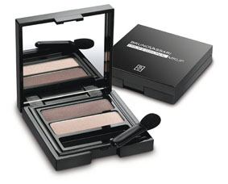**Make-up :**

|  |  |  |  |
| --- | --- | --- | --- |
| ref. | DESCRIPTION | Achat € | Vente € |
| 0259 | Prof.Mkcare - Kiss me Balm | 8,25 | 16,50 |
| 5193 | Fortalecedor – Nail strengthener | 7,65 | 15,30 |
| 5466 | Nail Polish nr.3 | 6,15 | 12,30 |
| 5467 | Nail Polish nr.4 | 6,15 | 12,30 |
| 5468 | Nail Polish nr.5 | 6,15 | 12,30 |
| 6182 | Nail Polish base & topcoat | 6,15 | 12,30 |
| 5464 | Nail Polish n1 | 6,15 | 12,30 |
| 5465 | Nail Polish n2 | 6,15 | 12,30 |
| 5459 | Pure Colour Lipstick nr.1 | 14,10 | 28,20 |
| 5460 | Pure Colour Lipstick nr.2 | 14,10 | 28,20 |
| 5461 | Pure Colour Lipstick nr.3 | 14,10 | 28,20 |
| 5462 | Pure Colour Lipstick nr.4 | 14,10 | 28,20 |
| 5463 | Pure Colour Lipstick nr.5 | 14,10 | 28,20 |
| 5550 | Precise Volume Mascara | 15,45 | 30,90 |
| 5634 | Terrabruna nº4 | 22,65 | 45,30 |
| 5788 | Soft Eyeliner (zwart) | 5,20 | 10,40 |
| 5790 | Soft Eyeliner (bruin) | 5,05 | 10,10 |
| 5910 | Duo Eye shadow nº1 | 14,85 | 29,70 |
| 5911 | Duo Eye shadow nº2 | 14,85 | 29,70 |
| 5917 | Duo Eye Shadow n°7 | 17,25 | 34,50 |
| 5918 | Duo Eye Shadow n°8 | 17,25 | 34,50 |
| 5417 | Skin Fusion SPF 15 N°1 | 25,05 | 50,10 |
| 5418 | Skin Fusion SPF 15 N°2 | 25,05 | 50,10 |

|  |  |  |  |
| --- | --- | --- | --- |
| A7283 | Prof.Mkcare – Presentatiestand BB Cream incl. testers | 18,00 |  |
| A0268 | Prof.Mkcare – BB Cream N.1 30ml (lichte kleur) | 25,35 | 50,70 |
| A0269 | Prof.Mkcare – BB Cream N.2 30 ml (donkere kleur) | 25,35 | 50,70 |

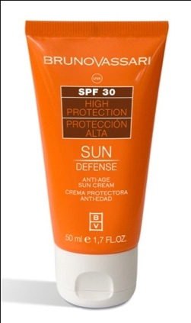**LIGNE SOLAIRE – SUN DEFENSE :**

|  |  |  |  |  |
| --- | --- | --- | --- | --- |
| DESCRIPTION | Ref. | Ml/gr/pcs | Achat € | Vente € |
| Anti Age Sun Cream SPF50+ | 4076 | 50 | 26,85 | 53,70 |
| Sunlight Protective Water SPF40 | 4081 | 200 | 41,10 | 82,20 |
| Natural & Mineral Sun Fluid SPF50 | 4083 | 50 | 39,45 | 78,90 |
| Sparkling Body Oil | 4082 | 100 | 30 | 60 |
| After Sun Lotion | 4084 | 200 | 24,60 | 49,20 |
| Sun Defense After Sun | 4074 | 200 | 24,60 | 49,20 |
| Sun Fluid Blue Protection SPF30 | 4079 | 50 | 26,10 | 52,20 |
| Oil Free Sun Spray SPF25 | 4078 | 200 | 25,80 | 51,60 |
| Sun Powder | 5830 | 1 | 26,10 | 52,20 |
| Sun Pocket Fluid SPF 50 | 4080 | 50 | 33,15 | 66,30 |
| Sun Protect Spray SPF30 | 4077 | 200 | 32,25 | 64,50 |

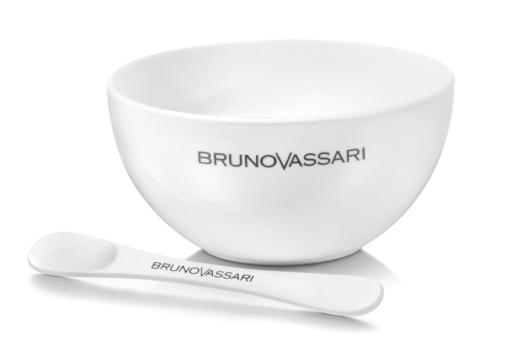

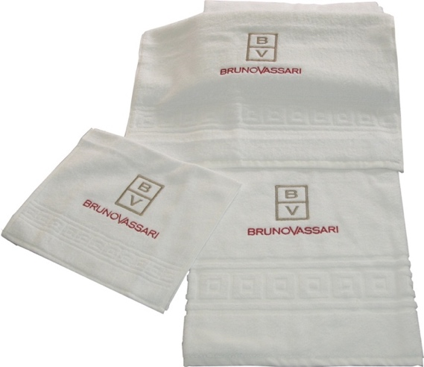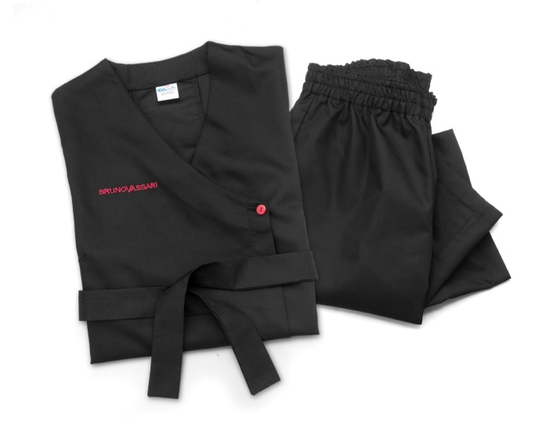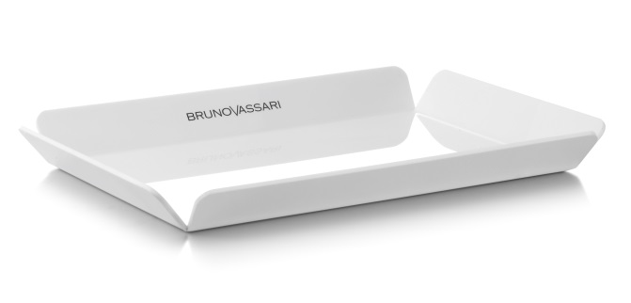

|  |  |  |  |
| --- | --- | --- | --- |
| DESCRIPTION | Ref. | Ml/gr/pcs | Achat € |
| Gants éponge | 9012 | 1 | 3,75 |
| Essui Petit BV 30*50 | 6140 | 1 | 2,10 |
| Essui Moyen BV 50*100 | 6139 | 1 | 4,80 |
| Essui Grand BV 100*150 | 6138 | 1 | 12,90 |
| Senses Essui Grand 100*180 | 6137 | 1 | 18,00 |
| Small Treatment Brush BV | 9070 | 1 | 6,00 |
| Big Treatment Brush BV | 9071 | 1 | 7,50 |
| Uniform Noir S-M-L | 6131 | 1 | 27,00 |
| Uniform Noir S-M-L | 6128 | 1 | 45,00 |
| Uniform blanc S-L | 6142 | 1 | 39,00 |
| Spatule | 9078 | 1 | 1,20 |
| Plateau BV | 6374 | 1 | 8,65 |
| Kom BV | 9077 | 1 | 2,40 |
| Séringe 5 ML | 9079 | 1 | 0,75 |
| BV couverture | 6120 | 1 | 27,00 |
| BV haarband | 6121 | 1 | 3,30 |
| BV Nature Mist | 0343 | 200 | 22,50 |
| Polyethylene Gloves | 6387 | 100 | 0,75 |
| Towel Mitten | 6388 | 1 | 7,50 |
| Bags For Feet | 6389 | 150 | 16,50 |